**INTRODUCTION**

Cells rely on the process of diffusion to obtain oxygen and nutrients and to rid themselves of carbon dioxide and other waste materials. These materials must be transferred across the cell membrane at a rate that keeps the cell alive. If the cell becomes too large, the demand for oxygen and nutrients and the production of waste exceeds the cell membrane’s capacity to transfer these materials with the outside environment.

Osmosis refers to the diffusion of water across a cell membrane. As the amount of solute on the outside of a cell changes, water will flow from an area of higher to lower water potential. Plant cells can accommodate changes in osmotic pressure better than animal cells because their cell wall helps to reduce the impact of water entering or leaving the cell.

**OBJECTIVES**

After completing this laboratory, you should be able to:

1. Describe the mechanisms of diffusion and osmosis.
2. Calculate surface-area-to-volume ratios for cells of different shapes and sizes.
3. Explain how surface-area-to-volume ratios impact rates of diffusion.
4. Describe the relationship between solutions that are hypotonic, hypertonic, and isotonic.
5. Describe how solute concentration impacts water potential.
6. Describe how pressure potential impacts water potential of a solution.
7. Calculate the water potential of living plant cells from experimental data.

**BACKGROUND**

Diffusion & Cell Size: One of the core principles that govern the efficiency of diffusion is the ratio of surface area to volume. Surface area is the amount of cell membrane available for diffusion, or how much diffusion that can happen at one time. Whereas volume is the amount of cytoplasm contained within the cell membrane. Therefore, volume is how long It takes to get from the membrane to the center of the cell by diffusion. To perform diffusion efficiently, there must be an adequate ratio between the cell’s surface area and its volume. But as a sphere or cube (the simplest models of cell shape) gets larger, its volume increases at a different rate than its surface area.

Modeling a Semi-Permeable Membrane with Dialysis Tubing: Dialysis tubing is made of a porous plastic that can be used to simulate the selective permeability of a cell membrane. Depending on the concentration of solutes inside and outside this model cell, water will either move into or out of the bag. The following terms are used to describe varying concentrations of solutes on one side of the membrane relative to the other side.

* **Hypertonic**: higher solute concentration relative to the other side of the membrane
* **Hypotonic**: lower solute concentration relative to the other side of the membrane
* **Isotonic**: equal solute concentration relative to the other side of the membrane

When a polar solute (like sucrose) dissolves in water, it is surrounded by hydration shells as the water interacts with it. The water involved in these hydration shells is not free to move around in solution as much as water that is “free”. Therefore, where there is a higher concentration of solutes, there will be less “free” water. You can also say that where there is a higher concentration of solutes, there is a lower water potential (for movement). Water will always diffuse across a membrane from an area of higher to lower water potential.

Determining the Water Potential of Potato Cells: Water potential refers to the potential energy of water. Where solute concentration is low, there is more “free” water and a higher water potential. This means that the water on this side of the membrane has a greater potential for movement. By placing potato cores in different concentrations of sucrose and measuring the percent change in mass, you will be able to determine the molar concentration and water potential of the cells for both russet and sweet potatoes.

**Procedures**

Diffusion & Cell Size

**CAUTION: The indicator phenolphthalein is a known carcinogen. The agar must be handled with protective gloves at all times and must be disposed of in the trash when finished. Sodium hydroxide (NaOH) is a strong acid. Use caution and wear protective eyewear while handling. If a spill should occur, notify your instructor at once. Take note of the location of the eyewash station in the classroom in case of emergency.**

1. Obtain a piece of phenolphthalein agar.
2. Use a ruler and a scalpel to cut model cells with the following dimensions:
   1. 0.5 x 0.5 x 0.5 cm
   2. 1 x 1 x 1 cm
   3. 0.5 x 0.5 x 4 cm
3. Fill three beakers with approximately 100mL of sodium hydroxide solution.
4. Drop all three cubes into the solution at the same time and begin a timer.
5. Note the color change that indicates the progress of NaOH diffusing into the agar cube.
6. Record the amount of time for the color change to progress all the way through each cube.

Modeling a Semi-Permeable Membrane with Dialysis Tubing

1. Obtain 2 strips of dialysis tubing. Tie a knot in the tube close to one end of the tube.
2. Obtain 10mL of one of your assigned sucrose solutions.
   1. You have a 10mL graduated cylinder in your basket. Use the plastic pipettes to transfer the solution to avoid spills.
3. Rub the tubing between your fingers to open it up.
4. Pour the sucrose solution from the graduated cylinder into the dialysis tubing.
5. Tie a knot at the other end of the dialysis tubing, leaving an air bubble between the solution and the knot.
6. Blot the outside of your dialysis tube dry using a paper towel.
7. Determine the initial mass (g) of the dialysis tube containing the solution and record below.
8. Thoroughly clean and dry a 250mL beaker.
9. Place the dialysis tube into the 250mL beaker and submerge in DI water.
10. Label the beaker with your name and the sucrose solution that is contained in the tubing.
11. Cover the beaker with a piece of aluminum foil and place the labeled beaker on the back table in the classroom to sit for at least 24 hours before determining your final mass (g).
12. Repeat steps 1-11 for your other assigned sucrose solution.

Determining the Water Potential of Potato Cells

1. Obtain one 250mL beaker and pour 100mL of one of your assigned sucrose solutions into the beaker.
2. Use your potato borer to produce four sweet potato cylinders.
   1. You may need the blunt probe in your basket to help push the cylinder out of the metal tube.
3. Remove any potato skin with your scalpel.
4. Determine the initial mass (g) of the four sweet potato cylinders together and record below.
5. Place all four cylinders into the beaker containing your sucrose solution.
   1. At this point, you may need to add a little bit more solution to submerge the cylinders as much as possible.
6. Label the beaker with your name and the sucrose solution that is bathing the cylinders.
7. Cover the beaker with a piece of aluminum foil and place the labeled beaker on the back table in the classroom to sit for at least 24 hours before determining your final mass (g).
8. Repeat steps 1-7 for your other assigned sucrose solution.
9. Repeat steps 1-8 with a russet potato.
   1. There are more russet potatoes on the front counter if you need them.

**Results**

Table 1: Surface-area-to-volume ratios and time for diffusion for various cell models

|  |  |  |  |  |
| --- | --- | --- | --- | --- |
| **Cell Size (cm)** | **Surface Area (cm2)** | **Volume (cm3)** | **SA/V** | **Time (min)** |
| 0.5 x 0.5 x 0.5 |  |  |  |  |
| 1 x 1 x 1 |  |  |  |  |
| 0.5 x 0.5 x 4 |  |  |  |  |

Create a graph that best displays the relationship between surface-area-to-volume-ratio and time for diffusion.

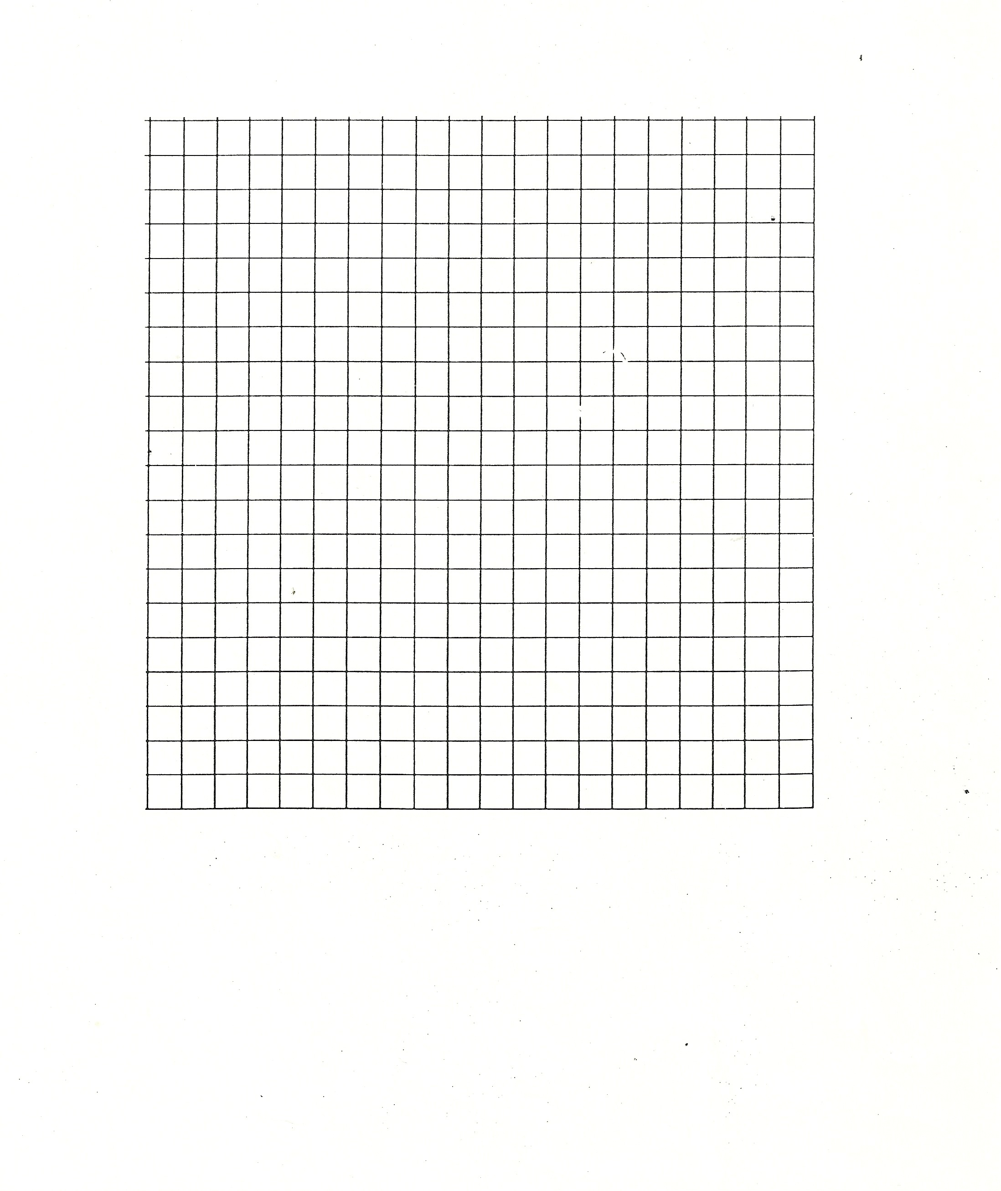

**Summary of Data:**

Table 2: Percent change in mass for dialysis tubing, sweet potatoes, and russet potatoes

|  |  |  |  |  |  |  |  |  |  |
| --- | --- | --- | --- | --- | --- | --- | --- | --- | --- |
| **Sucrose Concentration (Molarity)** | **Dialysis Tubing Mass (g)** | | | **Sweet Potato Mass (g)** | | | **Russet Potato Mass (g)** | | |
| **Mi** | **Mf** | **%Change** | **Mi** | **Mf** | **%Change** | **Mi** | **Mf** | **%Change** |
| Distilled water |  |  |  |  |  |  |  |  |  |
| 0.2 M |  |  |  |  |  |  |  |  |  |
| 0.4 M |  |  |  |  |  |  |  |  |  |
| 0.6 M |  |  |  |  |  |  |  |  |  |
| 0.8 M |  |  |  |  |  |  |  |  |  |
| 1 M |  |  |  |  |  |  |  |  |  |

Create two graphs that best display the following:

1. The relationship between percent change in mass of dialysis tubing and sucrose concentration
2. The relationship between percent change in mass of sweet potato and russet potato and sucrose concentration



**Summary of Data:**

**Water Potential Calculations**

|  |  |
| --- | --- |
| Water Potential | Solute Potential |
|  |  |

Modeling a Semi-Permeable Membrane with Dialysis Tubing

1. Use the molarities to calculate the solute potential of the cells.
2. Calculate the water potential for the russet and sweet potato cells.

|  |  |  |  |  |  |  |
| --- | --- | --- | --- | --- | --- | --- |
| Sucrose Concentration (M) | **0M** | **0.2 M** | **0.4 M** | **0.6 M** | **0.8 M** | **1 M** |
| Solute Potential |  |  |  |  |  |  |
| Water Potential |  |  |  |  |  |  |

Do these calculations support the trend seen in the line of best fit in graph a? Why or why not?

Determining the Water Potential of Potato Cells

1. Using the lines of best fit produced in graph b, determine the molarity of the russet and sweet potato cells.
2. Use the molarities from the graph to calculate the solute potential of the cells.
3. Calculate the water potential for the russet and sweet potato cells.

|  |  |  |
| --- | --- | --- |
|  | **Russet** | **Sweet** |
| Molarity (M) |  |  |
| Solute Potential |  |  |
| Water Potential |  |  |

Compare the water potential of the potato cells to the water potential of each sucrose solution.Do these calculations support the trend seen in the line of best fit in graph b? Why or why not?

**Post-Lab Data Analysis**

1. For each of the following dialysis tubing concentrations, draw a diagram that represents where there was a greater concentration of solutes and show the directional movement of water. Be sure to use correct vocabulary (hypertonic, hypotonic, isotonic, free water/water potential, etc.) to summarize the diagram.

|  |  |  |
| --- | --- | --- |
| Concentration (M) | **Labeled Diagram** | **Summary** |
| 1 |  |  |
| 0.8 |  |  |
| 0.6 |  |  |
| 0.4 |  |  |
| 0.2 |  |  |
| DI Water |  |  |

1. For each of the following scenarios, draw a diagram that represents where there was a greater concentration of solutes and show the directional movement of water. Be sure to use correct vocabulary (hypertonic, hypotonic, isotonic, free water/water potential, etc.) to label the diagram.

|  |  |  |
| --- | --- | --- |
| Concentration (M) | Potato Cylinders | |
| **Russet Potato** | **Sweet Potato** |
| 1 |  |  |
| 0.8 |  |  |
| 0.6 |  |  |
| 0.4 |  |  |
| 0.2 |  |  |
| DI Water |  |  |

1. For the model agar cells **describe a model** that explains how surface area to volume ratios impact the rate of diffusion. Use claim, evidence reasoning (CER).
2. For the potato cylinders, **describe a model** that explains what the inside and outside of the cells look like at the concentration where the line of best fit crosses the X-axis. Use claim, evidence reasoning (CER). Be sure to use correct vocabulary (hypertonic, hypotonic, isotonic, free water/water potential, etc.) to complete your argument.
3. **Describe** the difference between the sucrose concentrations of russet and sweet potatoes. Use claim, evidence reasoning (CER).